### CHAPTER 1

**INTRODUCTION**

* 1. **PROJECT OVERVIEW**

## Safe and readily available water is important for public health, whether it is used for drinking, domestic use, food production or recreational purposes. Better water supplies and sanitation, as well as better management of water resources, can contribute greatly to poverty reduction and economic growth. It is known that contaminated water and inadequate sanitation facilitate the transmission of diseases such as cholera, diarrhoea, dysentery, hepatitis A, typhoid, and polio. Those without access to clean water and sanitation face preventable health risks. We are going to implement a water quality prediction using machine learning techniques. In this technique, our model predicts that the water is safe to drink or not using some parameters like Ph value, conductivity, hardness, etc

* 1. **PURPOSE**

## The purpose of this research is to develop a reliable method for forecasting water quality with a proposed model as precisely as necessary.

The following are the suitable approaches:In this study, missing data is handled using the Random Forest approach, and the dataset is splitting using the min-max normalization technique.Describe and demonstrate the dataset’s significant distribution and feature correlation.Based on prior research, select the most important features for WQC and categorize three distinct types of water quality based on WQI rate.SVM, NN, MLR, BTM, and RF algorithms are used to optimize model performance.The proposed model approaches: develop a software application that uses the MLR algorithm to predict water quality in real time for these three types of WQ.

### EXISTING PROBLEMS

**CHAPTER 2 LITERATURE SURVEY**

|  |  |  |
| --- | --- | --- |
| **S.NO** | **AUTHOR’S NAME** | **PROPOSED WORK** |
| **1** | Daud et al | Gathered water samples from different areas of Pakistan and tested them against different parameters using a manual lab analysis and found a high presence of E. coli and fecal coliform due to industrial and sewerage waste. |
| **2** | Alamgir et al | Tested 46 different samples from Orangi town, Karachi, using manual lab analysis and found them tobe high in and total fecal coliform count.After getting familiar with the water quality research concerning Pakistan, we explored research Employing machine learning methodologies in the realm of water quality. |
| **3** | Shafi et al | Estimated water quality using classical machine learning algorithms namely, Support Vector Machines (SVM), Neural Networks (NN), Deep Neural Networks (Deep NN) and k Nearest Neighbors (kNN), with the highest accuracy of 93% with Deep NN |
| **4** | Ahmad et al | Employed single feed forward neural networks and a combination of multiple neural networks toestimate the WQI. They  used 25 water quality parameters as the |

|  |  |  |
| --- | --- | --- |
|  |  | input. Using a combination of backward elimination and forward selection selective combination methods, they achieved an R2 and MSE of 0.9270, 0.9390 and 0.1200,  0.1158, respectively. The use of 25 parameters makes their solution a little immoderate in terms of an inexpensive real time system, given the price of the parameter  sensors. |
| **5** | Sakizadeh | Predicted the WQI using 16 water quality parameters and ANN with Bayesian regularization. |
| **6** | Rankovic et al. | Predicted the dissolved  oxygen (DO) using a feedforward neural network (FNN). They used 10 parameters to predict the DO,  which again defeats the purpose if it has to be used for a Real time WQI estimation of an IOT system. |

**Table 2.1 - Existing Problems**

### REFERENCES

* + 1. [TH Aldhyani, M Al-Yaari, H Alkahtani, and M Maashi, Water quality prediction using](https://doi.org/10.1155/2020/6659314) [artificial intelligence algorithms, Applied Bionics and Biomechanics, Vol. 2020, 2020,](https://doi.org/10.1155/2020/6659314) [pp. 6659314.](https://doi.org/10.1155/2020/6659314)
    2. [U Ahmed, R Mumtaz, H Anwar, AA Shah, R Irfan, and J García-Nieto, Efficient water](https://doi.org/10.3390/w11112210) [quality prediction using supervised machine learning, Water, Vol. 11, 2019, pp. 2210.](https://doi.org/10.3390/w11112210)
    3. [P Liu, J Wang, AK Sangaiah, Y Xie, and X Yin, Analysis and prediction of water](https://doi.org/10.3390/su11072058) [qualit usingLSTM deep neural networks in IoT environment, Sustainability, Vol. 11,](https://doi.org/10.3390/su11072058) [2019, pp. 2058.](https://doi.org/10.3390/su11072058)
    4. [L Wang, Z Zhu, L Sassoubre, G Yu, C Liao, Q Hu, et al., Improving the robustness of](https://doi.org/10.1016/j.scitotenv.2020.142760) [beach water quality modeling using an ensemble machine learning approach, Science of](https://doi.org/10.1016/j.scitotenv.2020.142760) [The Total Environment, Vol. 765, 2021, pp. 142760.](https://doi.org/10.1016/j.scitotenv.2020.142760)
  1. **PROBLEM STATEMENT DEFINITION**

## Safe and readily available water is important for public health, whether it is used for drinking, domestic use, food production or recreationa**l** purposes. Better water supplies and sanitation, as well as better management of water resources, can contribute greatly to poverty reduction and economic growth. It is known that contaminated water and inadequate sanitation facilitate the transmission of diseases such as cholera, diarrhoea, dysentery, hepatitis A, typhoid, and polio. Those without access to clean water and sanitation face preventable health risks.

We are going to implement a water quality prediction using machine learning techniques. In this technique, our model predicts that the water is safe to drink or not using some parameters like Ph value, conductivity, hardness, etc.

|  |  |
| --- | --- |
| **Who does the problem?** | People who are drinking impure water. |
| **What is the issue?** | Poor quality of potable, domestic use , or even recreational water  due to contamination can lead to human illness. |
| **When does the issue occurs?** | Contact with suspended materials and elements such as sand, boulders and biological matter in rivers  ,streams and lakes causes water to become undrinkable a non-pure water. |
| **Why is it important that we fix the problem?** | By solving this issue, people who drinking impure water can drink pure water. |

**Table 2.2 - Problem Statement Deﬁnition**

### CHAPTER 3 IDEATION AND PROPOSED SOLUTION

* 1. **EMPATHY MAP CANVAS**

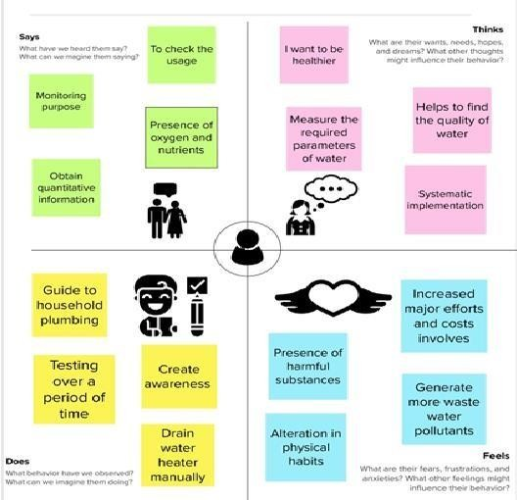

### Figure 3.1 - Empathy Map

An empathy map is a widely-used visualization tool within the ﬁeld. In relation to **empathetic** design, the primary purpose of an empathy map is to bridge the understanding of the end user.

### IDEATION AND

**BRAINSTORMINGStep-1:**

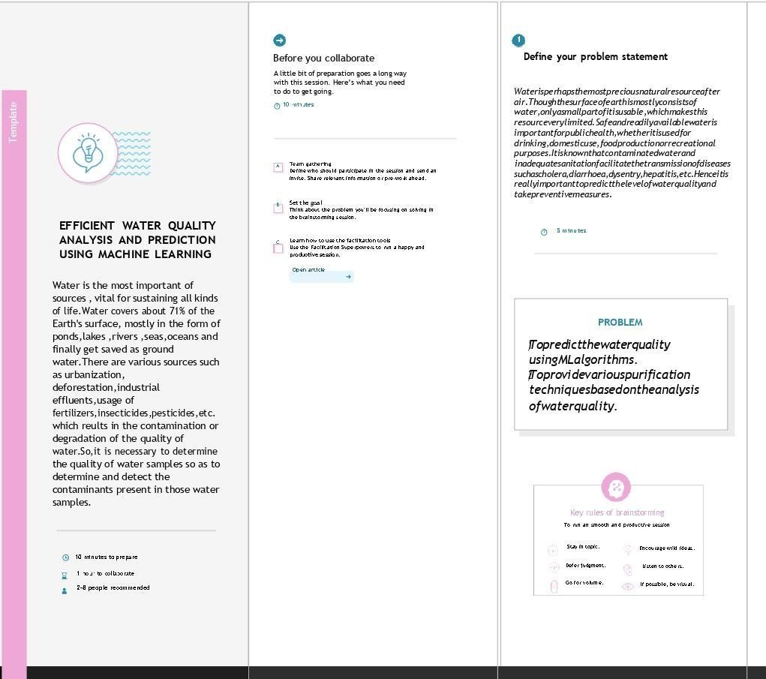

**Figure 3.2 - Ideation and Brainstorming**

A principal difference between ideation and brainstorming is that ideation is commonly more thought of as being an individual pursuit, while brainstorming is almost always a group activity.

### Step 2:

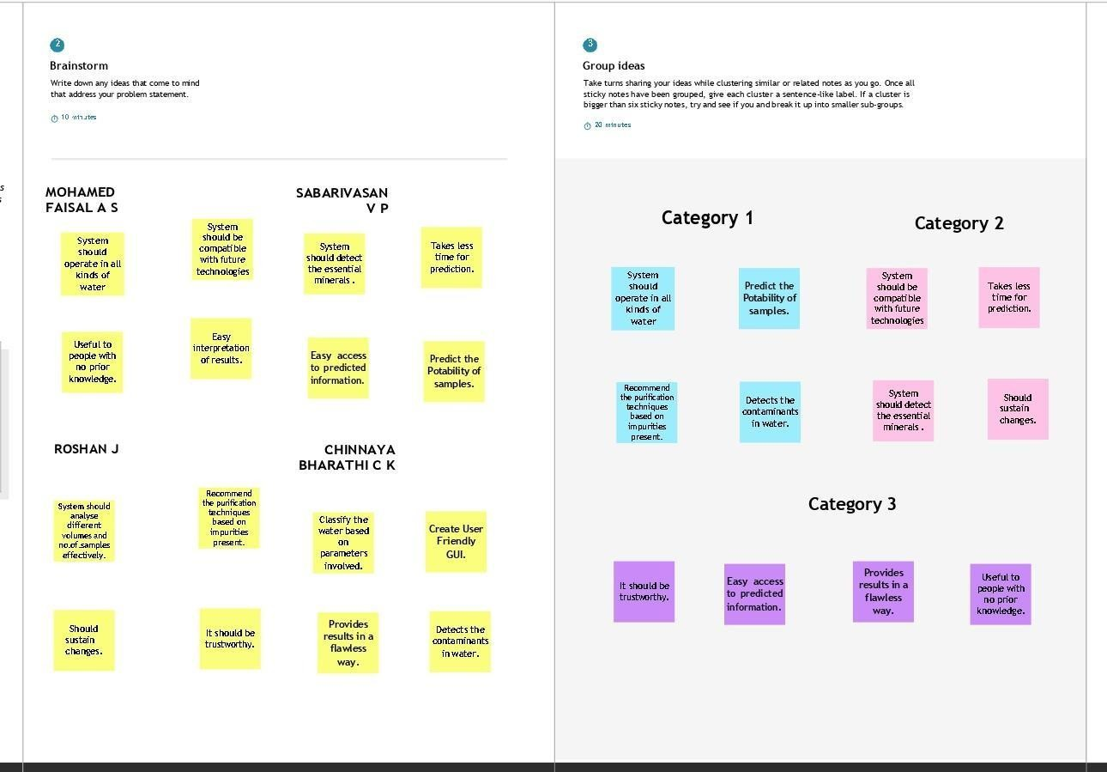

**Figure 3.3 - Brainstorm, Idea Listing and Grouping**

The idea listing and grouping is used to organize and analyse large numbers of ideas by categorising them. By organising and reorganising ideas, students gain a better appreciation of, and dialogue about, their ideas. As students create idea clusters, new contexts and connections among themes emerge.

### Step 3:

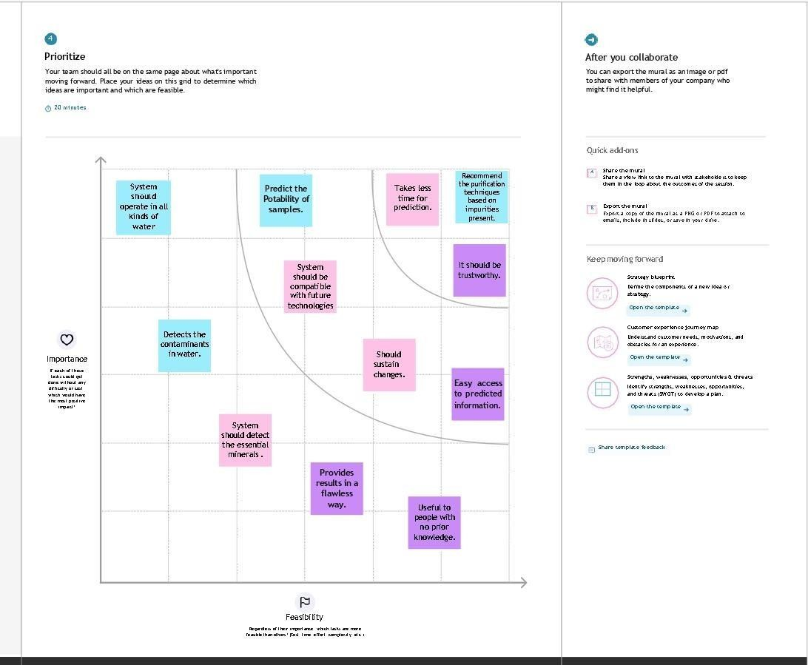

**Figure 3.4 - Idea Prioritization**

|  |  |  |  |  |
| --- | --- | --- | --- | --- |
| Idea prioritization is just a part of the idea management process. Having a structured idea management process and a systematic way of gathering, evaluating and prioritizing new ideas takes time. To make it work, the entire idea management process should be integrated to the everyday ways of working.  **3.3 PROPOSED SOLUTION** | | | | |
|  | **S.No.** | **PARAMETERS** | **DESCRIPTION** |  |
| 1. | Problem Statement (Problem to be solved) | At recent times water pollution have risen due to human activities and others. Due to this drinking water is not safe and there is a need to check for the water quality before using it for various purposes. |
| 2. | Idea/Solution description | An analyzer allows to collect data about water and analyses the quality of the water and predicts the quality percentage of it and based on which we can utilize it. |
| 3. | Novelty / Uniqueness | This analyzer is more efficient and allows user to get results in a better and more efficient way.  This also utilizes needed data alone compared to others and provides more precise prediction. |
|  |  |  |  |  |

|  |  |  |
| --- | --- | --- |
| 4. | Social Impact / Customer Satisfaction | Since our project use efficient and low cost components it provides the product in very low price. It also has no harm towards the environment. |
| 5. | Scalability of the Solution | Since our project use efficient and low cost components it provides the product in very low price. It also has no harm towards  the environment. |

**Table 3.1 - Proposed Solution**

### 3.4 PROBLEM SOLUTION FIT

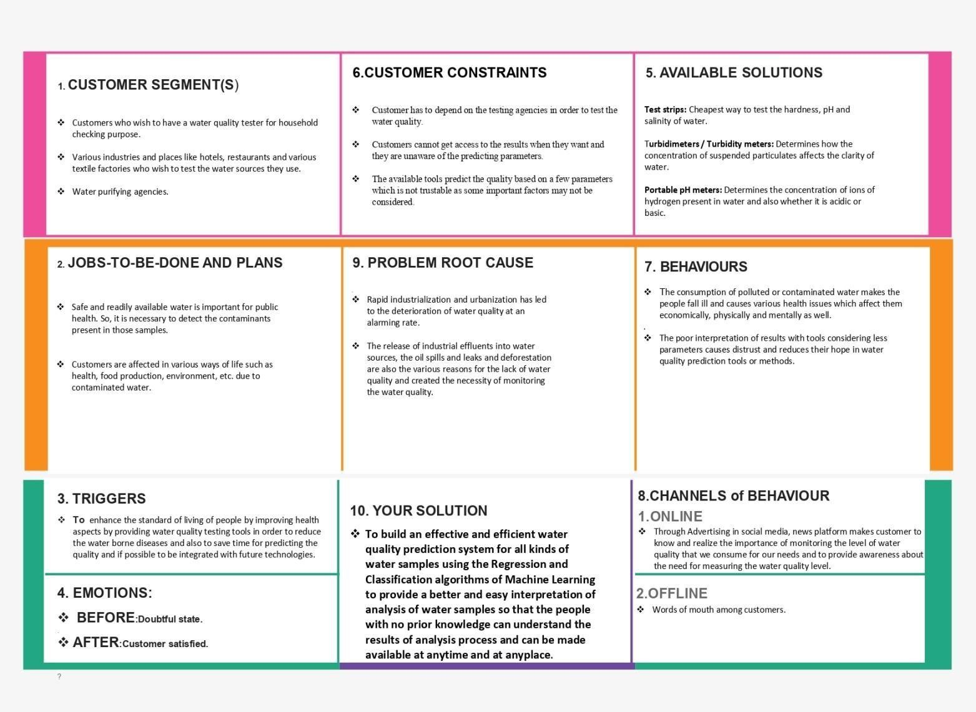

**Figure 3.5 - Solution ﬁt of design with user requirements**

|  |  |  |  |  |  |
| --- | --- | --- | --- | --- | --- |
|  | | | | | |
|  | This occurs when the user have evidence that customers care about certain jobs, pains, and gains. At this stage the user proved the existence of a problem and have designed a value proposition that addresses customers' jobs, pains and gains.  **CHAPTER 4 REQUIREMENT ANALYSIS**  4.1 **Functional Requirements:**  Following are the functional requirements of the proposed solution. | | | | |
|  | **FR No.** | **Functional Requirement(Epic)** | **Sub Requirement (Story / Sub-Task)** |  |
| FR-1 | User Registration | Registration through Form. Registration through Gmail. |
| FR-2 | User Confirmation | Confirmation via Email.Confirmation via OTP. |
| FR-3 | User Login/ Authentication | Validation of Login ID and password. |
| FR-4 | Machine Learning Model Deployment | Develop the Machine Learning Regression Modelto predict the Water Quality Index (WQI).Develop the Machine Learning ClassificationModel to predict theWater Quality Classification (WQC). |
| FR-5 | Testing The Water Samples | Provides an option to test any kind of water sampleswith required parameters and to calculate the Water Quality Index and  impurities present. |
| FR-6 | Interface Function | Provides an interface to :   1. View the Water Quality Index value. 2. Display the Water Sample type. 3. Produce any purification techniquerecommended for the sample. |
| FR-7 | Reporting | If any issues are faced by the customer or user itwill be directly notified to the developer. |
| FR-8 | Compliance to Rules or Laws | Privacy Policy, Terms and Conditions and End UserAgreement. |
|  | | | | |

### Non-functional Requirements:

Following are the non-functional requirements of the proposed solution.

|  |  |  |
| --- | --- | --- |
| **FR No.** | **Non-Functional Requirement** | **Description** |
| NFR-1 | **Usability** | Customers can access the system moreefficiently and in a simpler way. The customers can have the opportunity to view a better interpretation of results. The customers are also recommended with the purification techniques based on the impurities. |
| NFR-2 | **Security** | All the predicted information is accessed only bythe authenticated users. |
| NFR-3 | **Reliability** | It should be reliable in producing effective and efficient water quality prediction results. It should ensure the trust and belief among people that this  water quality prediction system produces correct results when used. |
| NFR-4 | **Performance** | The system should be consistent in producing the prediction results of Water Quality Index (WQI) and also needs to ensure better throughput and response time compared to othersystems. |
| NFR-5 | **Availability** | The system can be utilised by the customers 24/7 and it should be availed to test any kind ofwater samples anywhere. |
| NFR-6 | **Scalability** | It can be used by wide variety of users like testing agencies, private and public laboratories, restaurants and hotels and people who wish to test the quality of water they consume. The system should also be compatible enough so as to be integrated with the future technologies also. |

### CHAPTER 5 PROJECT DESIGN

* 1. **DATAFLOW DIAGRAMS**

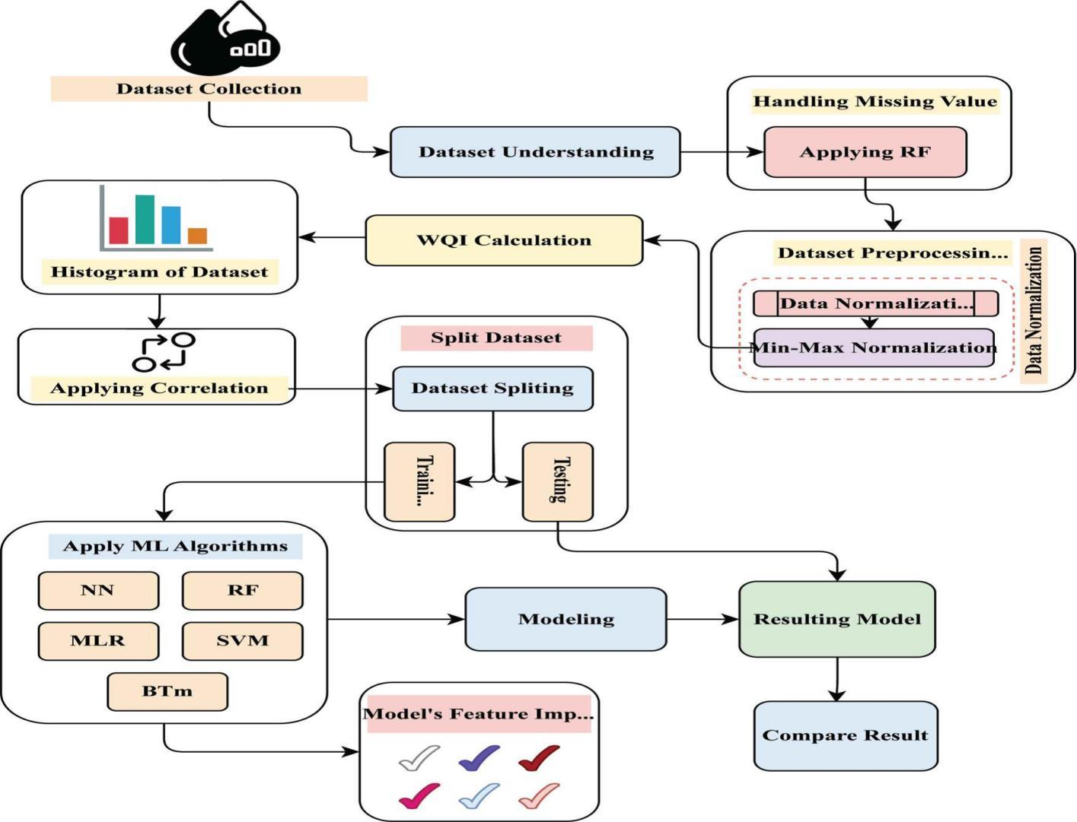

**Figure 5.1 - Data ﬂow Diagram**

A data ﬂow diagram is a graphical or visual representation using a standardized set of symbols and notations to describe a business's operations through data movement. They are often elements of a formal methodology such as Structured Systems Analysis and Design Method.

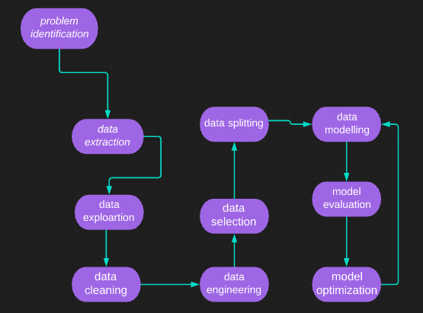**Figure 5.2 - Describes the ﬂow of the project deployment**

The ﬂow through which applications, modules, updates, and patches are delivered from developers to users. The methods used by developers to build, test and deploy new code will impact how fast a product can respond to changesin customer preferences or requirements and the quality of each change.

### SOLUTION AND TECHNICAL ARCHITECTURE

Solution Architects are most similar to project managers, ensuring that all parties, including stakeholders, are on the same page and moving in the right direction at all stages. Technical architects manage all activities leading to the successful implementation of a new application. A solution architect must have a technical background with at least eight years of work experience in one or more IT areas including but not limited to: IT architecture, infrastructure, and cloud development.

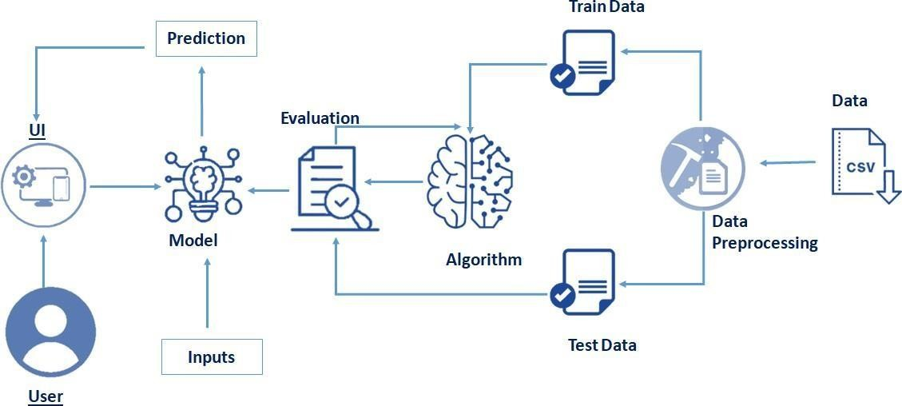

**Figure 5.2 - The process of architecttural description**

### MODEL PERFORMANCE AND TESTING

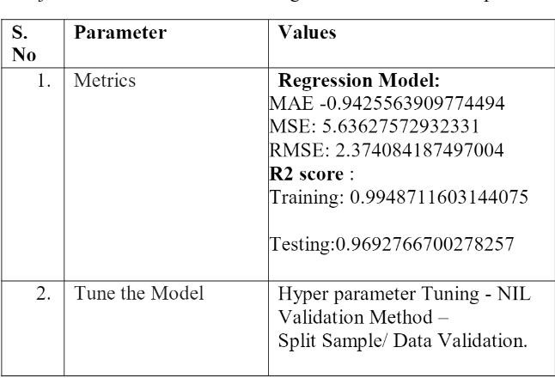

**Table 5.3 Model performance testing**

### CHAPTER 6

**PROJECT PLANNING AND SCHEDULING**

### 6.1 SPRINT PLANNING AND ESTIMATION

|  |  |  |  |  |  |  |
| --- | --- | --- | --- | --- | --- | --- |
| **Sprint** | **Functional Requirement (Epic)** | **User Story Number** | **User Story / Task** | **Story Points** | **Priority** | **Team Members** |
| Sprint-1 | Data Collection | USN-1 | Collect the appropriate dataset for predicting the water quality. | 10 | High | Mohamedfaisal.AS |
| Sprint-1 |  | USN-2 | Data Preprocessing – Used to transform the data into useful format. | 7 | Medium | Roshan.J  Chinnayabharathi.CK Mohamedfaisal.AS |
| Sprint-2 | Model Building | USN-3 | Calculate the Water Quality Index (WQI)  using Regression algorithm of MachineLearning. | 10 | High | Sabarivasan.VP  Chinnayabharathi.CK Mohamedfaisal.A |
| Sprint-2 |  | USN-4 | Splitting the Model into Training for Testing from the overall dataset. | 7 | Medium | Mohamedfaisal.AS Roshan.J |
| Sprint-3 | Training and Testing | USN-5 | Train the Model using Regression algorithm and Testing the Performance of the model. | 10 | High | Sabarivasan.VP Chinnayabharathi.CK |
| Sprint-4 | Implementatio n ofthe Application | USN-6 | Predict the Water Quality Index (WQI) and  recommend the appropriate purificationtechnique. | 10 | High | Sabarivasan.VP Chinnayabharathi.CK Mohamedfaisal.AS |
| Sprint-4 |  | USN-7 | Deploy the Model on IBM Cloud. | 7 | Medium | Sabarivasan.VP Chinnayabharathi.CK Mohamedfaisal.AS  Roshan.J |

**Table 6.1 - Sprint planning and estimation**

### SPRINT DELIVERY SCHEDULE

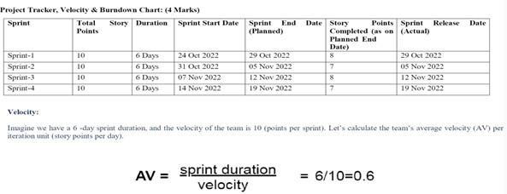

**Table 6.2 - Sprint Delivery Schedule**

### REPORTS FROM JIRA Burdown Chart

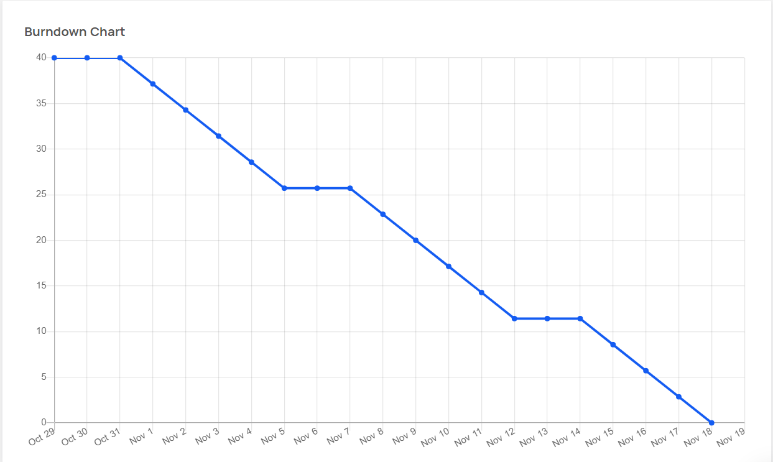

**Figure 6.1 - Burndown Chart**

A burndown chart shows the amount of work that has been completed in anepic or sprint, and the total work remaining. Burndown charts are used to predict your team's likelihood of completing their work in the time available.

### Burnup Chart

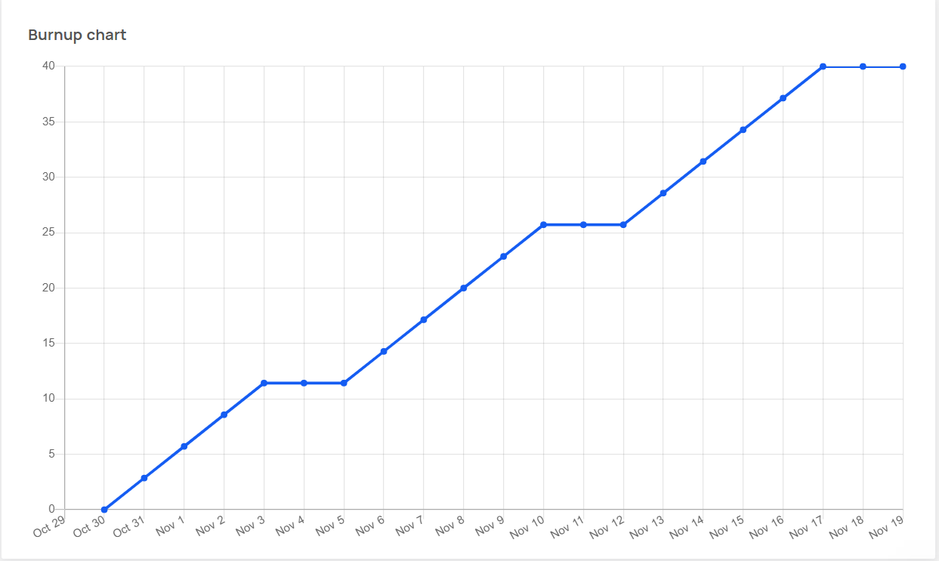

**Figure 6.2 - Burnup Chart**

A burnup chart highlights the work you've completed against your total project scope while a burn down chart highlights the amount of work remaining in a project. A burnup chart contains a work completed line and a project scope line.It displays the scope of a project and the work completed

### FEATURE 1

**CHAPTER 7 CODING AND SOLUTION**

The ﬁrst feature of the deployement is the process of Random Forest Classiﬁer is used to train and test the model for detecting the water quality withthe help of collected and pre-processed dataset collections.

# Train Test Split:

from sklearn.model_selection import train_test_split X_train,X_test,y_train,y_test=train_test_split(X_smote,y_smote,

test_size=0.3, random_state=33)

Random forest is a Supervised Machine Learning Algorithm that is used widely in Classiﬁcation and Regression problems. It builds decision trees on different samples and takes their majority vote for classiﬁcation and average incase of regression.

# RandomForestClassiﬁer:

from sklearn.ensemble

import RandomForestClassiﬁer RandomForest = RandomForestClassiﬁer()

RandomForest = RandomForest.ﬁt(X_train,y_train) # Predictions:

y_pred = RandomForest.predict(X_test)

# Performance:

print('Accuracy:', accuracy_score(y_test,y_pred)) print(confusion_matrix(y_test,y_pred))

print(classiﬁcation_report(y_test,y_pred))

Gradient boosting classiﬁers are a group of machine learning algorithms that combine many weak learning models together to create a strong predictive model. Decision trees are usually used when doing gradient boosting.

# GradientBoostingClassiﬁer:

from sklearn.ensemble import GradientBoostingClassiﬁer GradientBoost = GradientBoostingClassiﬁer() GradientBoost = GradientBoost.ﬁt(X_train,y_train)

# Predictions:

y_pred = GradientBoost.predict(X_test)

# Performance:

print('Accuracy:', accuracy_score(y_test,y_pred)) print(confusion_matrix(y_test,y_pred)) print(classiﬁcation_report(y_test,y_pred))

### FEATURE 2

Python ﬂask is the ﬁrst feature that helps to complete this project. Itallows the user to create local server and host the website in a local machine.

from ﬂask import Flask, render_template, request import numpy as np

import pickle

Here we import all the necessary features of this project involving in Pythonﬂask.

import numpy as np

from flask import Flask,render_template,request import pickle

app = Flask( name )

model = pickle.load(open('wqi.pkl','rb')) @app.route('/about')

def about():

return render_template("about.html") @app.route('/')

def home() :

return render_template("predict.html") @app.route('/bod')

def bod():

return render_template("bod.html") @app.route('/col')

def col():

return render_template("col.html") @app.route('/do')

def do():

return render_template("do.html") @app.route('/nit')

def nit():

return render_template("nit.html") @app.route('/ph')

def ph():

return render_template("ph.html") @app.route('/cond')

def cond():

return render_template("cond.html") @app.route('/analysis')

def analysis():

return render_template("analysis.html") @app.route('/login',methods = ['POST']) def login() :

year = request.form["year"] do = request.form["do"]

ph = request.form["ph"] co = request.form["co"] bod = request.form["bod"] na = request.form["na"]

tc = request.form["tc"]

total = [[int(year),float(do),float(ph),float(co),float(bod),float(na),float(tc)]]

y_pred = model.predict(total) print(y_pred)

y_pred =y_pred[[0]]

if(y_pred >= 95 and y_pred <= 100) :

return render_template("predict.html",showcase = 'Excellent,The predicted value is '+ str(y_pred)+' No Purification or Treatment of Water is needed.')

elif(y_pred >= 89 and y_pred <= 94) :

return render_template("predict.html",showcase = 'Very good,The predicted value is '+str(y_pred)+' Minor Purification or Treatment of Water is needed.')

elif(y_pred >= 80 and y_pred <= 88) :

return render_template("predict.html",showcase = 'Good,The predicted value is'+str(y_pred)+' Conventional Purification or Treatment of Water is needed.')

elif(y_pred >= 65 and y_pred <= 79) :

return render_template("predict.html",showcase = 'Fair,The predicted value is '+str(y_pred)+' Extensive Purification or Treatment of Water is needed.')

elif(y_pred >= 45 and y_pred <= 64) :

return render_template("predict.html",showcase = 'Marginal,The predicted value is '+str(y_pred)+' Doubtful in purifying and treating the water so as to get Pure Water.')

else :

return render_template("predict.html",showcase = 'Poor,The predicted value is '+str(y_pred)+' The Water is not fit for to be used for Drinking.')

if name == ' main ' :

app.run()

Here we use the inputs from the html pages which has to be get by using request method in Python Flask. By validating the values from the database, weallow the user to access the home page. render_template: Used for rendering html pages on browser. url_for: Passing the control of the program to another function. session: Creates a separate session for the individual use.

<html>

<title>water quality prediction</title>

<style>

*{

}

.pd{

margin:0; padding:0;

text-decoration:none; font-family:montserrat;

padding-bottom:100%;} body

{

background-image:url('https://tenor.com/view/fallwater-gif-8021595.gif'); background-position: center;

font-family:sans-serif; background-size:cover; margin-top:40px;

}

.main{

background-color:rgb(0,0,0,0.6); width:800px;

height:500px; margin:auto; position:center;

border-top-left-radius:100px; border-bottom-right-radius:100px;

}

.main input[type="text"],.main input[type="text"],.main input[type="text"],.main input[type="text"],.main input[type="text"],.main input[type="text"]{

border:0; background:none; display:block; margin:20px auto; text-align:center;

border:2px solid #3498db; padding:10px 3px; width:200px; outline:none;

color:white; border-radius:24px; transition:0.25s;

}

.main input[type="text"]:focus,.main input[type="text"]:focus,.main input[type="text"]:focus,.main input[type="text"]:focus,.main input[type="text"]:focus,.main input[type="text"]:focus{

width:280px;

border-color:#8e44ad;

}

.logbtn{

display:block; width:35%; height:50px; border:none; border-radius:24px;

background:linear-gradient(120deg,#3498db,#8e44ad,#3498db); background-size:200%;

color:#fff;

outline:none; cursor:pointer; transition:.5s;

}

.logbtn:hover{

background-position:right;

}

.predict{ color:black;

text-align:center;

}

</style>

<body>

<center><img src="https://i.pinimg.com/236x/4b/bb/7d/4bbb7dae1470c8cdc3821b7c5b2f10fb.jpg" height="100"><b class="pd"><font color="white" size="15" font-family="Comic Sans MS"

>Water Quality Prediction</font></b></center>

<a href="/about" target="_blank"><font color="white" size="12" font-family="Comic Sans MS" >Why To Find Water Quality</font></a>

<form action="y_predict" class="main" method="post">

<br>

<center><input type="text" name="Station" placeholder="Station" required="required"

/>

<input type="text" name="Dissolved Oxygen" placeholder="Dissolved Oxygen"

required="required" />

<input type="text" name="PH" placeholder="PH" required="required" />

<input type="text" name="Carbon Monoxide" placeholder="Carbon Monoxide" required="required" />

<input type="text" name="Biochemical Oxygen Demand" placeholder="Biochemical oxygen Demand" required="required" />

<input type="text" name="Sodium" placeholder="Sodium" required="required" />

<input type="text" name="Technetium" placeholder="Technetium" required="required" />

<button type="submit" class="logbtn">Predict</button></center>

</form>

<br>

<br>

<h1 class=predict> {{ prediction_text }}</h1>

</body>

</html>

### CHAPTER 8 TESTING

**8.1 TEST CASES**

|  |  |  |  |
| --- | --- | --- | --- |
| **TEST CASE ID** | 15358 | **TEST CASE DESCRIPTION** | **EFFICIENT WATER QUALITY**  **ANALYSIS AND PREDICTION USING MACHINE LEARNING** |

|  |  |  |
| --- | --- | --- |
| **S.No.** | **PREREQUISITES** | **TEST DATA** |
| 1 | Access to Chrome Browser | By clicking the website link |
| 2 | Entering the details required | Details should be in a integer format |
| 3 | Check for correct values | Data sholud be filled |
| 4 | Application to train the model | Provide the datasets for model training |

### Test Scenario :

**Table 8.1 - Test Details**

|  |  |  |  |  |
| --- | --- | --- | --- | --- |
| **Step** | **Step Details** | **Expected Results** | **Actual Results** | **Pass/Fail/Not/**  **Executed/ Suspended** |
| 1 | Navigate to  website link | Site should  open | As Expected | pass |
| 2 | Enter the details | Details should be  entered | As Expected | pass |
| 3 | Click Submit | Check the result | As Expected | Pass |
| 4 | Output results | Result are  generated | As Expected | Pass |

**Table 8.2 - Test Cases**

### ER ACCEPTANCE TESTING

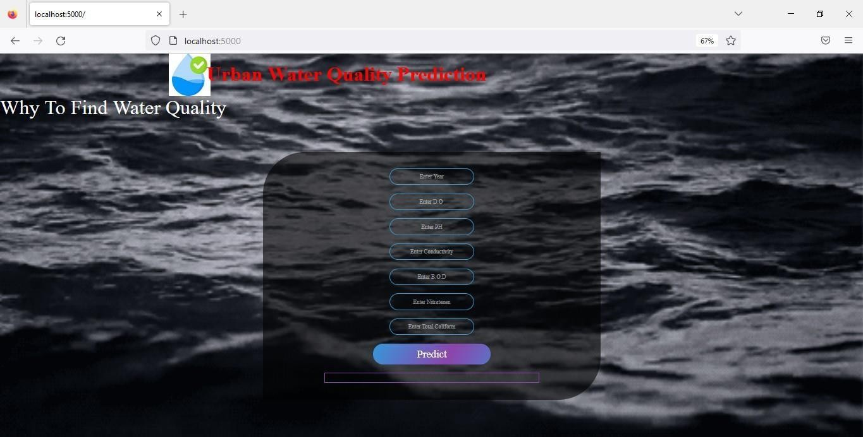

**Figure 8.1 - User Acceptance Test 1**

In this the user will be entering tested values which is moved for prediction.

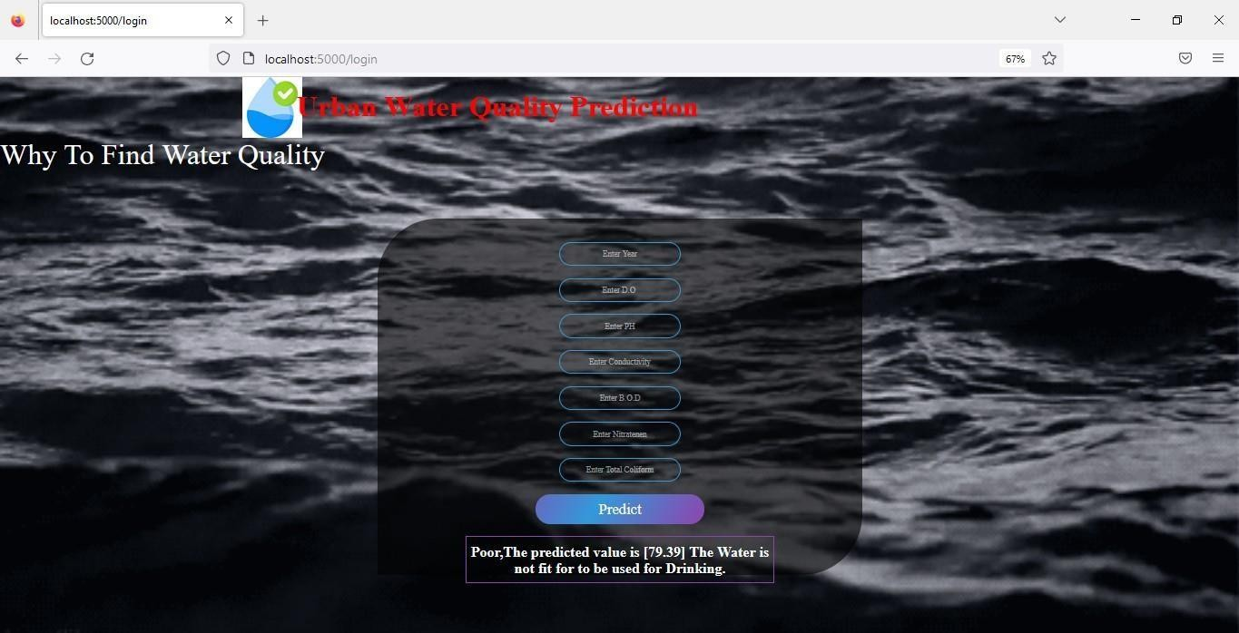

**Figure 8.2 - User Acceptance Test 2**

In this the data which was entered by the user will be analyzed

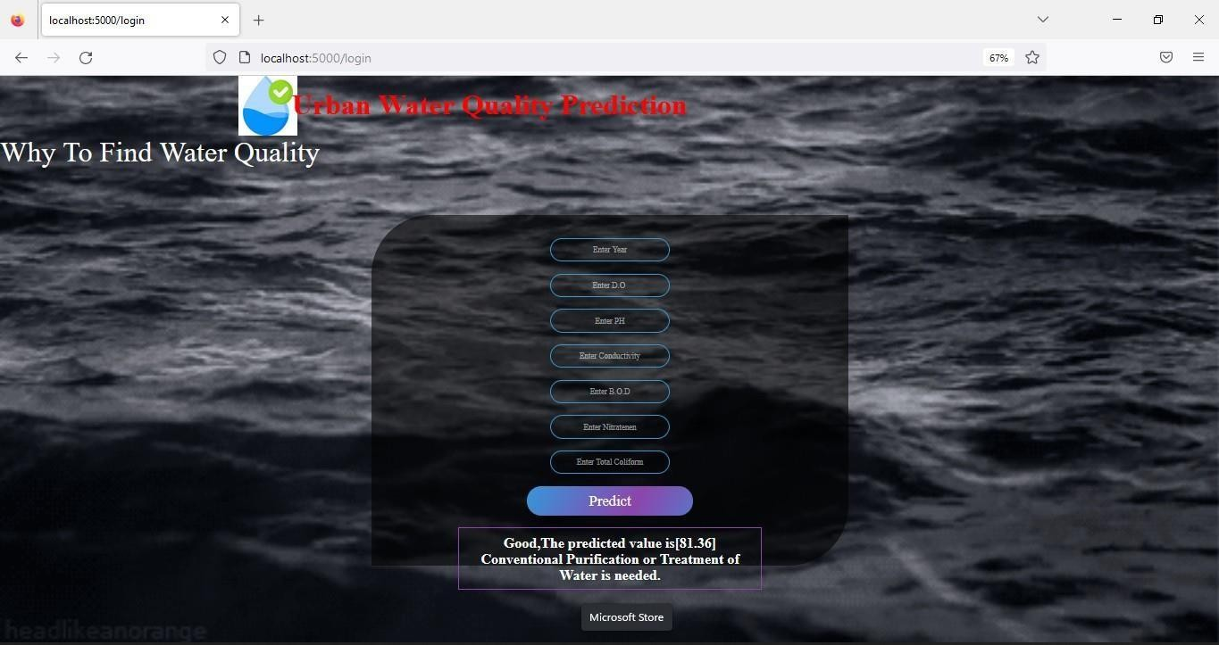

**Figure 8.3 - User Acceptance Test 3**

In this the data which was entered by the user will be analyzed

### CHAPTER 9 RESULTS

**9.1 PERFORMANCE METRICS**

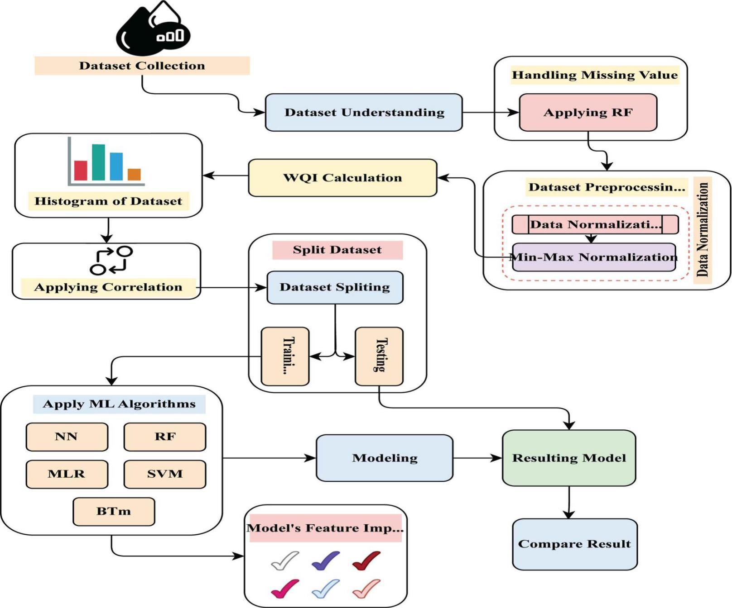

**Figure 9.1 - Flow of the Performance**

Performance Metrics is performed along for all the above assigned tasks. In each and every tasks various metrics is performed inorder to provide the optimum outcome.Results gives the best outcome as expected in project.



**Figure 9.2 - Performance Matrix**

### CHAPTER 10 ADVANTAGES AND DISADVANTAGES

**ADVANTAGES**:

Predicting the quality of drinkable water may reduce the incidence of water-related diseases.

The latest machine learning approach has shown promising predictive accuracy for water quality. The evaluation and prediction of source water quality based on machine learning can assist in the early warning and control of pollution.

### CHAPTER 11 CONCLUSION

The performance of machine learning techniques such as RF, NN, MLR, SVM, and BTM to predict the water quality components of an Indian water quality dataset was evaluated in this work. The most well-known dataset variables, such as BOD, DO, TC, Nitrate, pH, and Temp, were obtained for this purpose. The findings revealed that the applied models performed well in forecasting water quality parameters; however, the greatest performance was linked with the MLR with Accuracy Upper. Further research will be done to build models that combine the proposed method with other techniques and deep learning approaches to improve the efficacy of the selection process.

### CHAPTER 12 FUTURE SCOPE

The study provides a frugal technique for eliminating water pollution in residential overhead tanks. They are used toassess water quality, and machine learning algorithms are used to forecast potential water pollution problems. To gather water parameters, the proposed system comprises multiple sensors interfaced with NodeMcU. The user is notified before the water turns contaminated. The implemented solution protects the water from pollution while still being cost efficient. The projects future scope includes detecting illnesses caused by numerous factors and devising the most effective plan to cleanthe tank.

### CHAPTER 13 APPENDIX

**SOURCE CODE:**

### Algorithm :

#Importing The Libraries import pandas as pd import numpy as np

import matplotlib.pyplot as plt import seaborn as sns

#Reading the Dataset data=pd.read_csv(path) #Exploratory Data Analysis

data.head() data.info() data.describe()

#Checking For Null Values And Handling Null Values data.isnull().any()

data.isnull().sum()

data.isnull().sum() #Data Visualization

# Univariate Analysis

for col in df.columns:

if df.dtypes[col]=='float64'or df.dtypes[col]=='int64': sns.boxplot(x=df[col]).set(xlabel=col)

plt.show()

# Bivariate Analysis

for col1 in df.columns:

if df.dtypes[col1]=='float64':

for col2 in ['wqi']:

if df.dtypes[col2]=='float64': sns.boxplot(x=df[col1],y=df[col2]).set(xlabel=[col1],ylabel=[col2]) plt.show()

#Splitting The Dataset Into Dependent And Independent Variable x=data.iloc[:,0:-1]

y=data.iloc[:,-1]

#Split The Dependent And Independent Features Into Train Set And TestSetfrom sklearn.model_selction import train_test_split xtrain.xtest,ytrain,ytest=train_test_split(x,y,test_size=0.2)

#Check the shape of both xtrain and xtest. xtrain.shape

xtest.shape

#importing the machine learning model from sklearn.svm import svc

from sklearn.ensemble import RandomForestClassiﬁerfrom sklearn.neighbors import KNeighborsClassiﬁer #initiailizing the machine learning models

svm=SVC() RFmodel=RandomForestClassiﬁer() KNNmodel=KNeighborsClassiﬁers() svm=SVC()

#Train the data with SVM model svm.ﬁt(xtrain,ytrain)

### Github and Project Video Demo Link Github Link:

<https://github.com/IBM-EPBL/IBM-Project-20034-1659711287>

### Project Video Demo Link:

### <https://drive.google.com/file/d/1F7RavekPEZK9oIZcLAY4ZTjZAG7Ml4K_/view?usp=drivesdk>